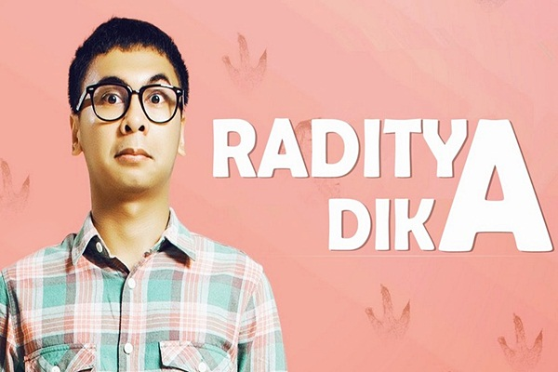

**Dika Angkasaputra Moerwani**, well-known by the name Raditya Dika is a young man from Jakarta. He was born on December 28th, 1984 in Jakarta. Radit (familiar) is a writer, actor, comedians, models, and also a very successful director in Indonesia.

The first work that made him famous was the book titled “*Kambing Jantan: Sebuah Catatan Harian Pelajar Bodoh in 2005*.” The book talked about his life when he was studying at the University of Adelaide, Australia.

Raditya told his stories as Indonesian students studying abroad. This book was displayed in a diary format. The whole story in his work came from his personal blog.

A year later, in 2006, he published his second book entitled “Cinta Brontosaurus.” This second book was almost the same as the previous book, the stories in the book raditya were mostly from his personal story.

In addition to writing style, the unique title of the book also made its own characteristics for Raditya Dika. Some of the other unique titles were; *Cinta Dalam Kardus, Manusia Setengah Salmon,*dan*Marmut Merah Jambu.*

**The Brief Biography of Raditya Dika in English**

**Full Name:** Dika Angkasaputra Moerwani

**Other Names:** Raditya Dika

**Place of Birth:** Jakarta

**Date of Birth:** Friday, December 28, 1984

**Zodiac:** Capricorn

**Nationality:** Indonesia

**Agama:** Islam

**Saudara:** Ingga dan Anggi (adik perempuan), Yudhit dan Edgar (adik laki-laki)

**Situs resmi:** radityadika.com

**Akun Twitter:** @radityadika

**Akun Instagram:** @raditya_dika

**Pendidikan:**SMP Tarakanita, SMU 70 Bulungan, University of Adelaide, dan Universitas Indonesia

**Novel:**

* Kambing Jantan: Sebuah Catatan Harian Pelajar Bodoh
* Cinta Brontosaurus tahun 2006
* Radikus Makankakus: Bukan Binatang Biasa tahun 2007
* Babi Ngesot: Datang Tak Diundang Pulang Tak Berkutang tahun 2008
* Marmut Merah Jambu tahun 2010
* Manusia Setengah Salmon tahun 2011
* Koala Kumal tahun 2015

**Film Raditya Dika**

* Kambing Jantan: The Movie tahun 2009
* Cinta Brontosaurus tahun 2013
* Cinta Dalam Kardus tahun 2013
* Manusia Setengah Salmon tahun 2013
* Marmut Merah Jambu tahun 2014
* Malam Minggu Miko The Movie tahun 2014
* SINGLE tahun 2015
* Sitkom Raditya Dika
* Malam Minggu Miko
* Comic Story

**Penulis skenario**

* Maling Kutang tahun 2009
* Cinta Brontosaurus tahun 2013
* Manusia Setengah Salmon tahun 2013
* Marmut Merah Jambu tahun 2014
* Comic Action di Kompas TV
* Stand Up Comedy Indonesia di Kompas TV
* Galau Nite di Metro TV
* Stand Up Comedy Academy di Indosiar